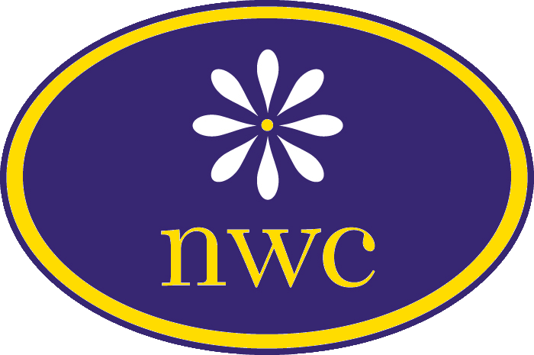
14 South Washington Street www.NapervilleWomansClub.org
Naperville, IL 60540 630.420.9680

Please check one: New Member Returning Member

Your image and/or voice may be shared via various media, including social media. You grant permission to publish your name, address, phone, and email in our Yearbook. Please initial to authorize use: __________

As a member, you agree to all policies and procedures of NWC:
- You will dispose of old directories in a responsible manner (shredding) or return to NWC for disposal.
- The membership list/information is CONFIDENTIAL and must not be used by any NWC member in the promotion of any business, nor may it be sold to anyone for any purpose, including charitable fundraising.

Name:
Optional Spouse/Partner name: Birthday:
Home Street Address:
City: State/Zip:
Home Phone: Cell Phone:
Email Address:

How did you find out about NWC? Facebook Website Attended one of our events
From a friend (friend’s name )

Each member is assigned to serve on at least one committee providing an opportunity to meet other members and to support the club’s charitable goals. (Check as many as you wish—the success of our philanthropic projects count on the volunteerism of our members.) In addition, all members will serve on at least one meetings committee (host and provide luncheon). My luncheon month choice is:

Arts: Art Fair plan committee
Young Adult Art Contest
Education: Scholarships
Member Learning Programs
Communications/Public Relations:
Email Announcements
Newsletter
Publicity
Photos
Telephone contacts
Yearbook publication
Website maintenance
Public Issues: Financial Philanthropy
Community Service Projects Leadership: Mentoring members/leaders
Meetings: Hospitality, decorating
Programs: Plan meeting programs
Membership: Recruit/orient new members
Ways & Means (planning committees, all members will assist in running these events):
Witches Night Out Naperville
Other
Facilities: Interior building needs
External repairs/landscape
Rentals

List special skills/talents you can offer NWC:

Club Year Dues (May 1 – April 30) are $70.00 via check Please make out your check payable to Naperville Woman’s Club and mail the check and this form to:
Naperville Woman’s Club
c/o Membership Chair
14 South Washington Street
Naperville, IL 60540
Please note that any bank fees charged for checks with insufficient funds are charged to the member who wrote the check.

